Ecovacs Warranty Process NZ
WARRANTY PROCESS
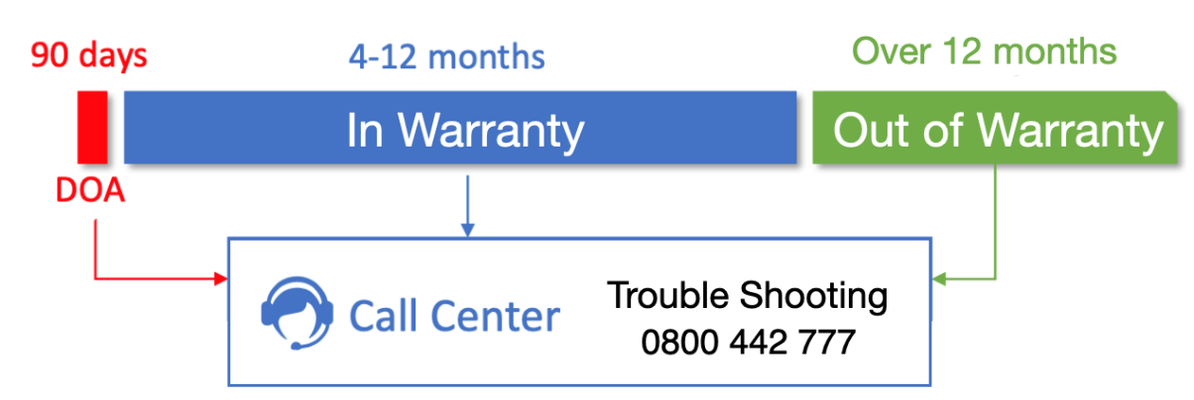
0800 447 918

DOA Process – 90 days from customer invoice
- Customer (or reseller on behalf of customer) calls Ecovacs call center for trouble shooting.
- If Ecovacs determine the unit is DOA, they will issue an RMA approval number.
- Reseller can refund/replace the unit for the customer and return the faulty unit through standard returns process along with RMA approval #.
- Reseller must ensure the below information is detailed when returning the unit back to Dicker Data NZ:
  - Ecovacs issued RMA#
  - SKU, SKU description
  - Detailed fault description
  - Unit serial number
  - Copy of original customer invoice for the unit

In Warranty Process – 4-12months from customer invoice
- Customer (or reseller on behalf of customer) calls Ecovacs call center for trouble shooting.
- If Ecovacs determine the unit is faulty and within the warranty period, they will issue an RMA approval number for replacement of the faulty unit.
- Reseller must download and complete the Dicker Data RMA form and submit it to returns.authorities.dickerdata.co.nz and ensure the below information is included when returning the unit back to Dicker Data NZ:
  - Ecovacs issued RMA#
  - SKU, SKU description
  - Detailed fault description
  - Unit serial number
  - Copy of original customer invoice for the unit

- Dicker Data NZ will respond with return approval and advise replacement of the unit from reseller store stock.
- The reseller then returns the faulty unit back through their standard returns process to Dicker Data NZ. The reseller must ensure the below information is detailed when returning the unit back to Dicker Data NZ:
  - Ecovacs issued RMA#
  - Dicker Data RMA number
  - Detailed fault description
  - Unit serial number
  - Copy of original customer invoice for the unit
Out of Warranty Process – over 12months from customer invoice

- Customer (or reseller on behalf of customer) calls Ecovacs call center for trouble shooting to see if the issue can be resolved.

- If the unit is deemed faulty outside of the 12month warranty period, the customer will not be eligible for refund or a replacement unit.

